Output Of Handling User Authentication

1.When we enter correct data in your code to check your debug in code

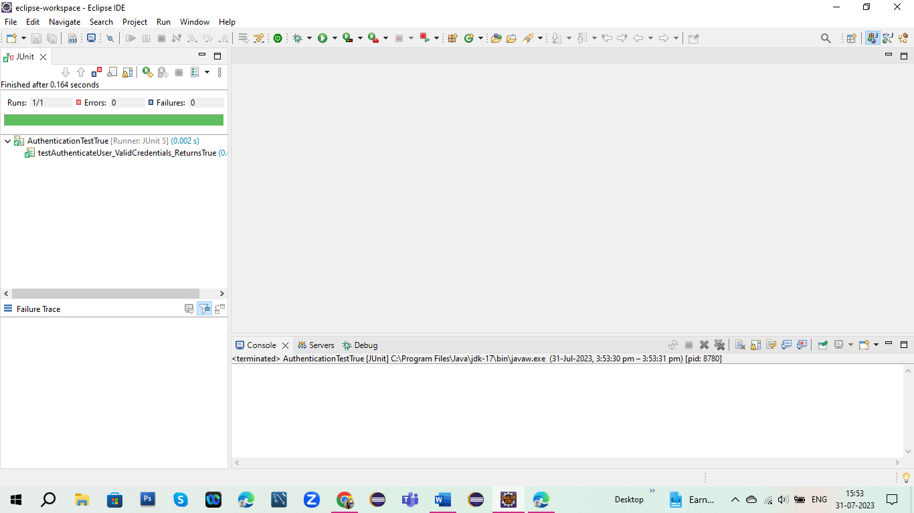

2.When we put wrong detail data in your code then we got debug

